# Linear Regression

## Intuition

## Linear Regression – Mathematical Understanding

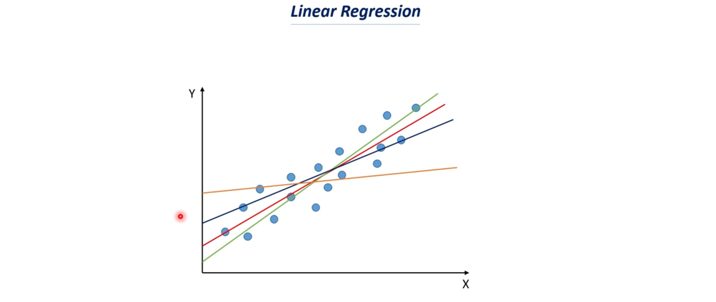

## Gradient Decent for Linear Regression

